‘Learning To Live Together’ Ethics Education training for Curriculum Developers of the National Institute of Education in Sri Lanka
(02nd March, 2012. Mortuwa, Sri Lanka)
Twenty curriculum developers from the National Institute of Education (NIE), took part in a special training workshop on ‘Learning To Live Together’ with the aim of integrating the concepts and approaches to the national school curriculum. Organized by the GNRC South Asia Secretariat at Sarvodaya in partnership with GIZ and the NIE, the workshop was held at the spiritual adobe, Sarvodaya Vishwanikethan International Peace Centre from 28th February to 1st March, 2012.
Workshop was inaugurated with the presence of Dr.A.T. Ariyaratne (Founder and President of the Sarvodaya Movement ), Mr. D.A. Perera ( Former Director General of the NIE), Ms. Elke Krause-Hannak (GIZ Advisor to the Ministry of Education), Dr. Lalitha Batuwitage ( GIZ staff and former Director – Social Sciences at NIE), who shared thoughts about the need, importance, past failures highlighting that the present moment is the right moment to bring ‘Learning To Live Together’ to the national curriculum and to the children of Sri Lanka.
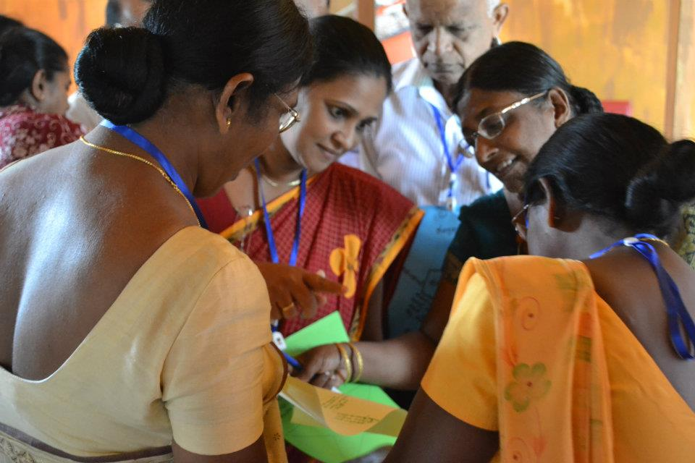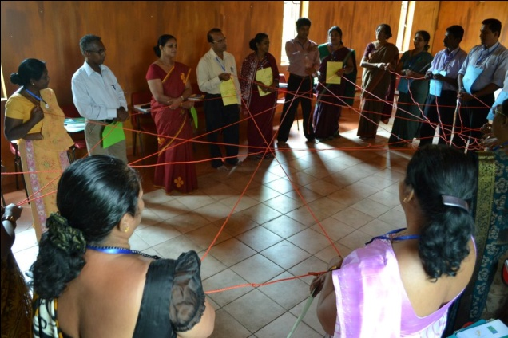
Over the three days of the workshops the participants unpacked concepts of Ethics, Values, Morals, Spirituality, Human and Child Rights looking at how to support children in developing competencies to live together in a pluralistic society through participatory learning approaches and methodologies. The workshop was not a merely a theoretical exercise but one that was filled with new experiences and encouraged introspection among the participants to apply the learning to their own lives.
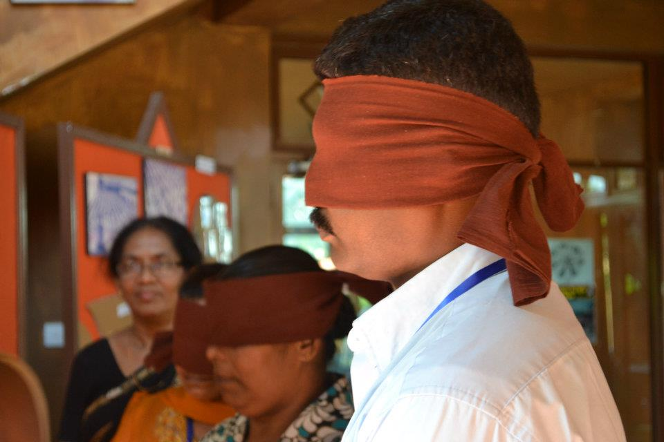 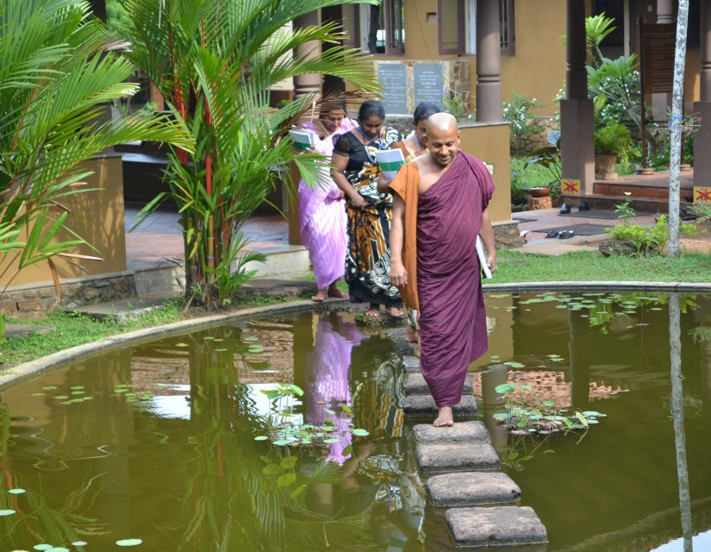
The participants were from various departments at the NIE responsible for curriculum development and teacher training for subjects including Mathematics, Languages, Science, Information Technology, Arts, Physical Education, Political Science and Civic Education. In indentifying the importance integrating ‘Learning To Live Together’ to the national curriculum agreed that whilst Civic Education as a subject gives the biggest space for addressing Ethics Education through ‘Learning To Live Together’ it is important to integrate the concepts and approaches to all subjects ensuring both vertical and horizontal integration.
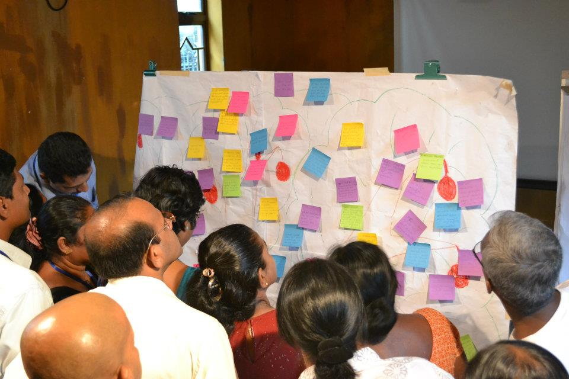 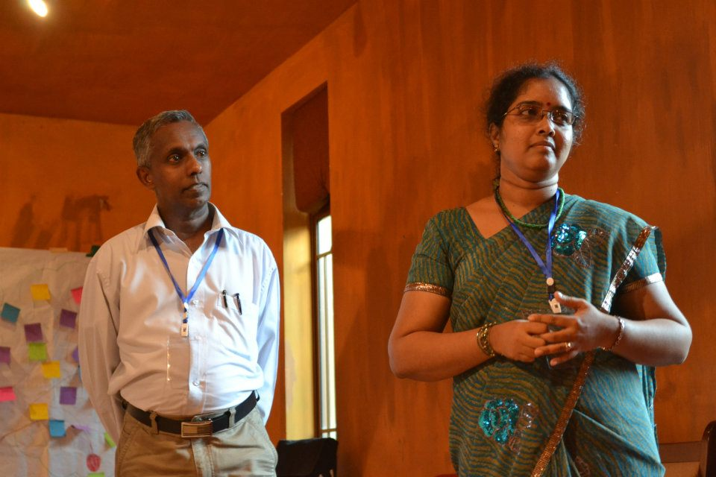
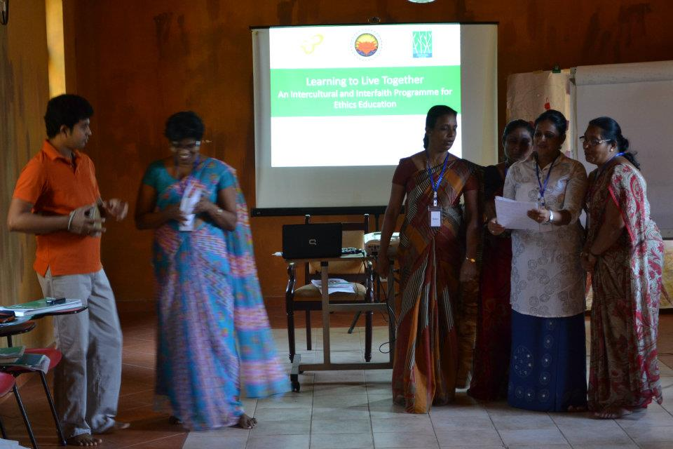 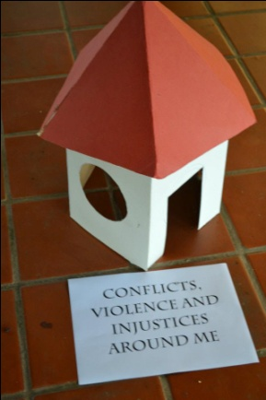 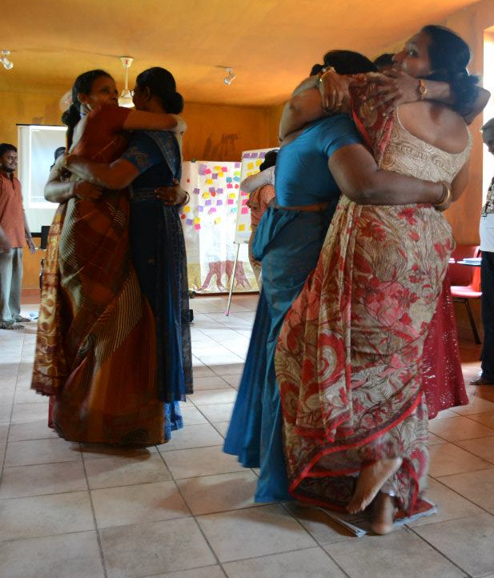
Comments from the participants were positive with one participant commenting “Learning To Live Together programme was a new experience for me and it’s concepts can be applied in the school curriculum. I invite you to organize a second workshop for this programme.”
One participant captured the relevance and the need for ‘Learning To Live Together’ in Sri Lankan society in expressing “ I highly recommend this type of workshops for the senior management and decision makers of Government and private sector institutions in our country.”
Workshop closed with the presence of Mr.S. Muralitharan and other Directors of the Ministry of Education and showing interest in having a similar training for the Ministry officials.
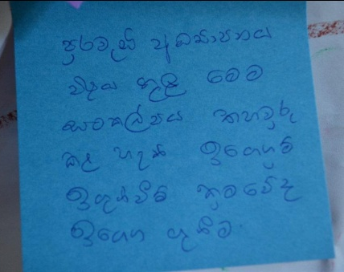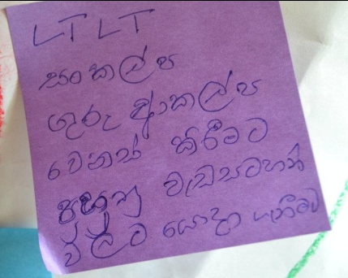 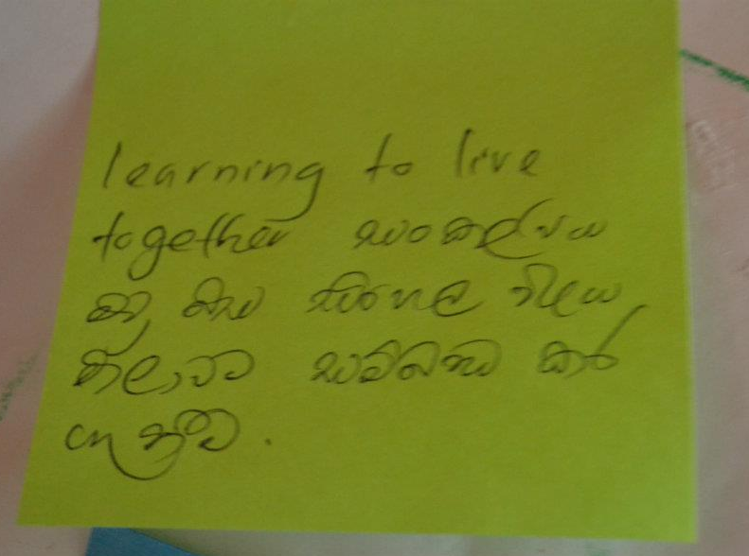
Following the positive response and requests for a second workshop, the group will meet again in the month of April, 2012 to deepen understanding on Ethics Education and take a closer look at how curriculum integration can take place during the curriculum revisions to take place from June, 2012 onwards. Another follow-up to the workshop will be to train at teacher trainers from the various National Colleges of Education (NCoE) through which teacher training
The workshop was lead by Mr. Suchith Abeyewickreme, the Project Manager for GNRC South Asia at Sarvodaya with the support of Mr. Sunil Abeywickrama, Senior Project Officer at the NIE, who was a participant at the previous Regional Training on Learning To Live Together organized by the GNRC South Asia Secretariat in August, 2011.
